

**CSEE-5110 0002, Fall 2016**

**Network Architecture**

**Project:**Socket Programming ‘Web-Server’ using Python

**Instructor:**Dr. Ken Mitchell

**Submitted by:**

* Ghosh Sovan
* Tarafdar Rajarshi
* Colaso Plamond
* Singh Harmeet
* Kapoor Adhirath

Sockets are endpoints which connects the client and the server together which is a peer to peer connection. Web Server is typically thought of as a long-running program that sends network messages only in response coming from the network. The other side of the protocol is a web client such as a browser, which always initiates communication with the server. The organization into client and server is used by most network – aware applications. Deciding that the client always initiates requests tends to simplify the protocol as well as the programs themselves.

Clients normally communication with one server at a time, although using a web browser we might able to communicate with many different web servers. But from the server’s perspective at any given point in time, is not usual for a server to be communicating with multiple clients.

Server IP

10.205.0.179

Client IP

10.205.0.191

Application Protocol

We have installed the web server on IP 10.205.0.179 which accepts and parse the HTTP request, get the requested file from the server’s file system, further on sends the response directly to the client on IP 10.205.0.191. When the requested file which is an HTML file is not present in the server, the server responds as “404 notfound” back to the client.

**Reference:**

We have got the idea of the code from the below website:

<http://www.cs.utexas.edu/~cannata/networking/Homework/WebServer.py>

**System Setup:**

Environment: windows 7

Software: python 2.6

Browser: Google Chrome

Language: Python

**Screen shots:**

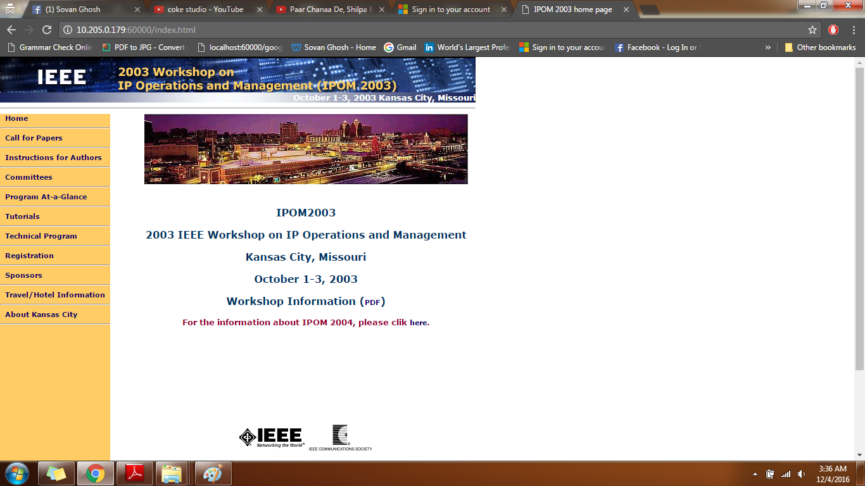First we show the connection on the Server side web browser as the connection accepted in the below screenshot. We have used Chrome as the Web browser and the port used is 60000.  
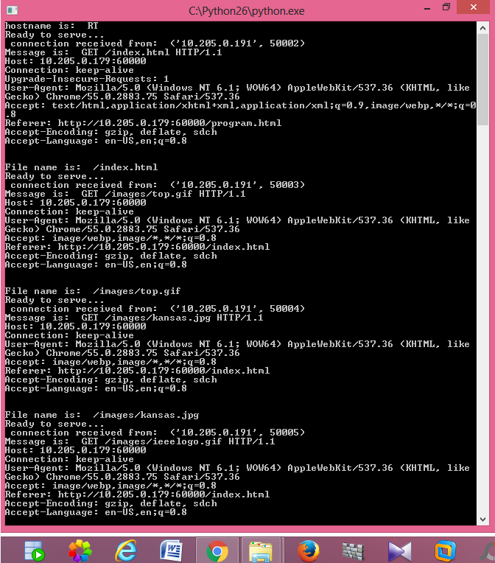

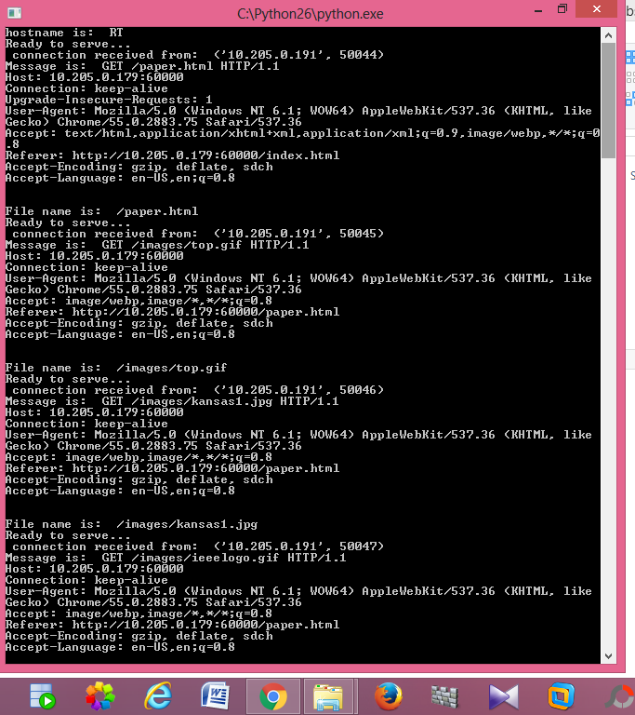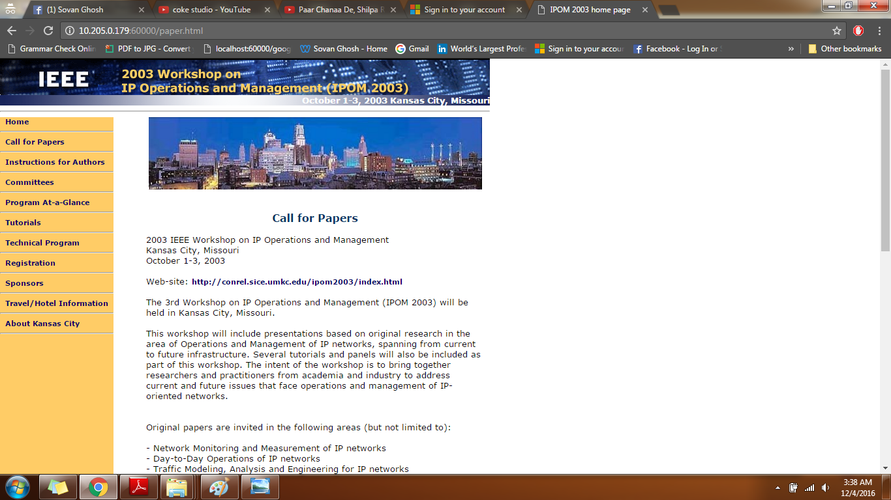

Now we show the connection on the Client side web browser by making the connection from the client to the server on port 60000. We were able to run the HTML on the client side as well.

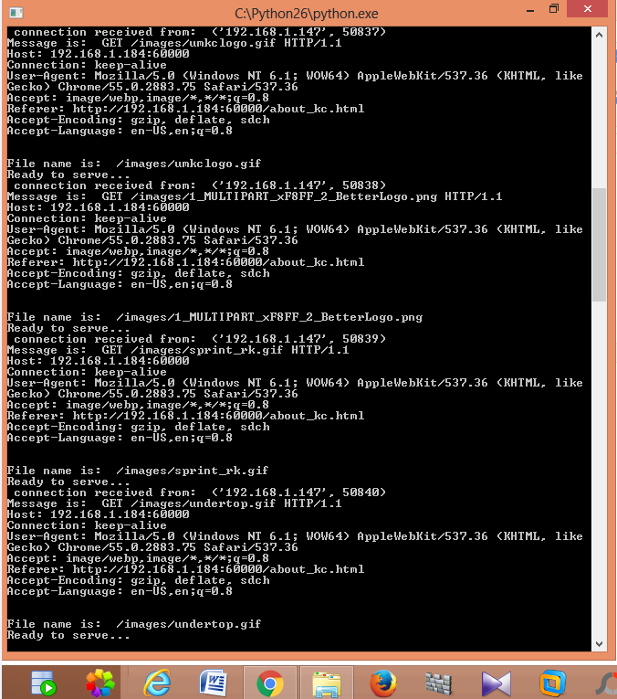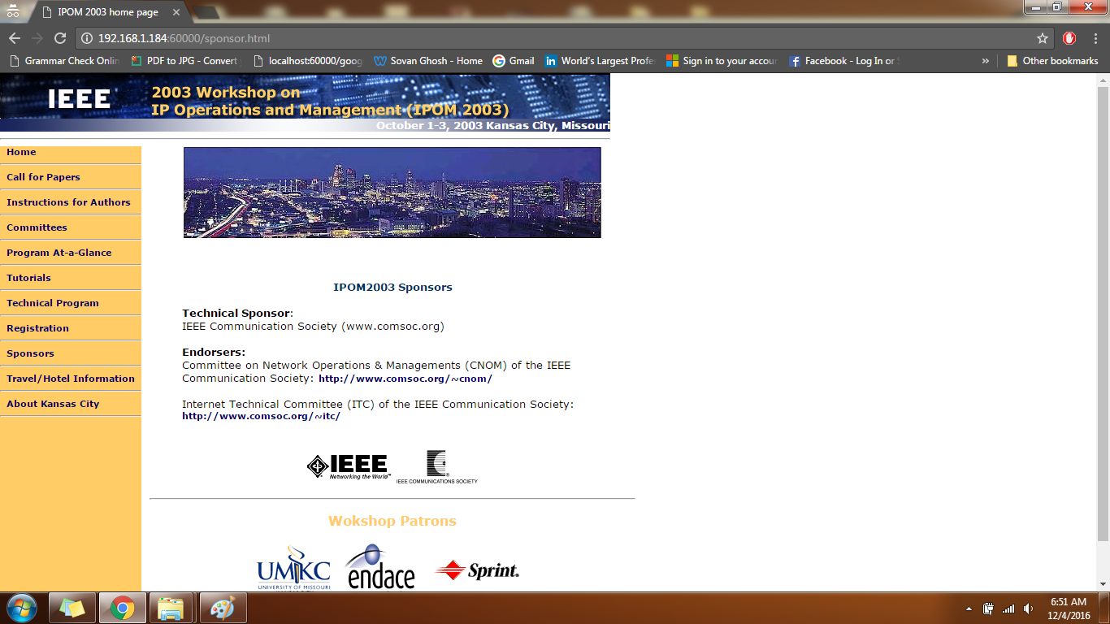

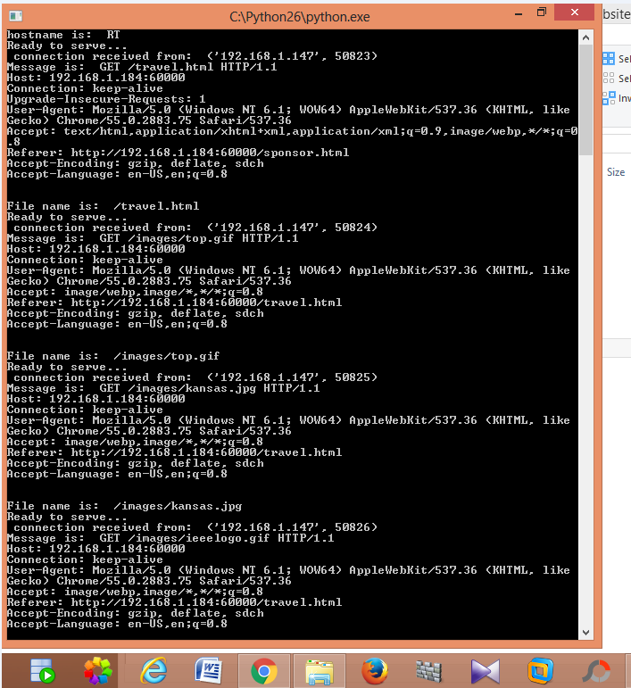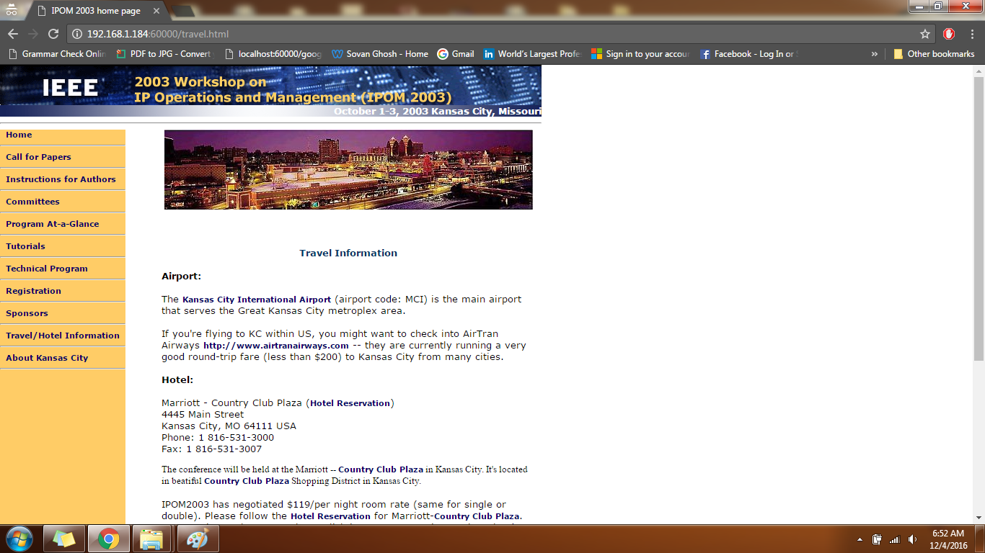

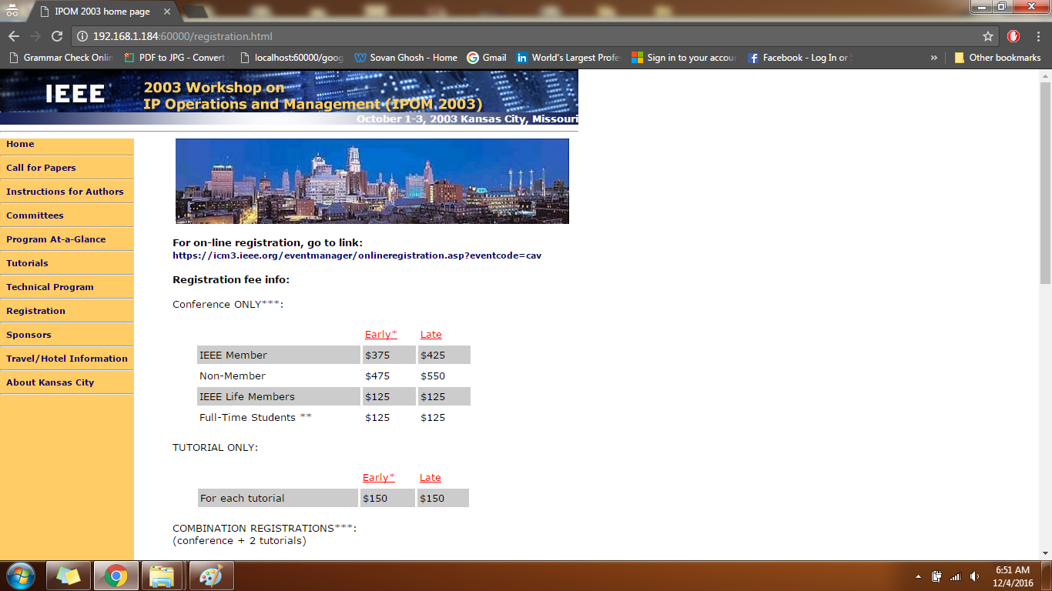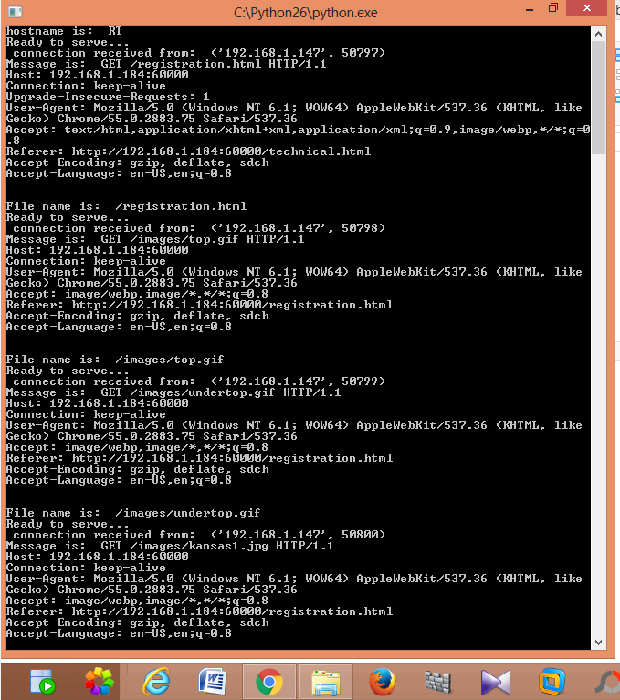

Also when we try to get the file that is not present at the server we get the error 404 file not found at both the client as well as on the server side.



**Academic dishonesty form:**